Announcing: New Enterprise Content Management Contract for Laserfiche (MCCi)
The State of Idaho put out an RFP in 2022 to contract with an Enterprise Content Management (ECM) provider to be the State Standard, capable of serving a variety of public entities with differing functional requirements. The state sought an off-the-shelf, on premises solution with hybrid cloud functionality. All new implementations, replacements for legacy and out of support ECM system and replacements of systems where cost effective to standardize will utilize the ECM solution awarded as a result of the solicitation. The state desired an effective way to purchase licensing and professional services to include migration of data, creation of workflow automation, training, consulting, business analytics, and requirements gathering.
MCCi was chosen as the vendor with their ECM offering Laserfiche. Laserfiche is a complete enterprise document content services system that combines powerful capture, processing, storage, retrieval and distribution of your documents and records. In addition to enterprise content management, Laserfiche provides drag-and-drop digital task automation for more efficient business process operation with built in security, auditing, and DoD 5015.2-certified records management functionality.
MCCi & ITS have put together an FAQ to help agencies that desire to learn more.
What is Laserfiche?
Laserfiche provides an easy-to-use, cost-effective platform to automate day-to-day business processes. With capabilities ranging from electronic records management to document routing, electronic forms, and integrations, Laserfiche is a powerful solution that enables the entire enterprise. The diagram below shows how the different components work together.
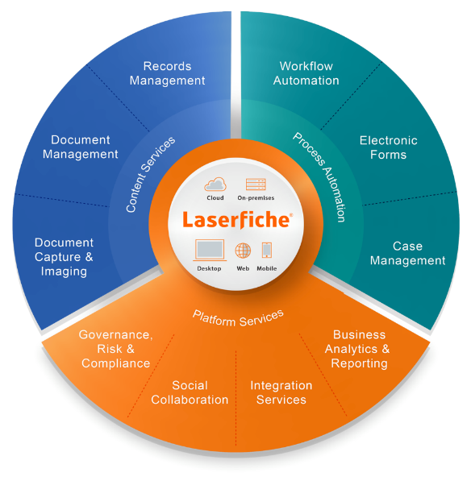
- Save costs through shared central support and eliminate the need for individual departments to maintain their own systems.
- Facilitate document sharing with colleagues while protecting confidential information.
- Enhance overall office efficiency by eliminating paper-based processes, improving information accessibility and decreasing the need to store paper documents.
- Ensure continuity of operations by securing records and providing web access to critical documents during emergencies.
- Streamline life-cycle management of business records with automatic enforcement of consistent, organization-wide records policies.
- Support compliance requirements for document retention.
- Maintain control of department documents with Laserfiche repositories.
- Protect documents from unauthorized access. Tools allow system administrators to set permissions for folders individuals can view and actions they can perform on documents.
- Track system activity with auditing and reporting tools.
- Increase office productivity by automating repetitive procedures, document routing and email notifications.
- Locate documents quickly with indexing tools and online search capabilities.

Do I need to use Laserfiche for ECM?
For new implementations, unless a valid business case exists to do otherwise, all new implementations should use the ITS supported Laserfiche product. Existing users of legacy systems other than Laserfiche are encouraged to consider transitioning to the preferred product when able to.

What are the costs?

Laserfiche implementations have a few components depending on the scope of the project. These include licensing, any additional support services needed and professional services. Licensing and additional support services are an annual cost.

How will support be provided?
ITS will provide central system administration and first-tier support. ITS has an agreement with MCCi for additional support services that the agencies can utilize through a chargeback model.

What are my agency's installation and administration requirements for Laserfiche?
For ITS supported agencies, ITS has an implementation of Laserfiche installed on ITS servers. New agencies can utilize this environment by having their own instance of Laserfiche that is managed by ITS and secure. Agencies also will need to allocate time and resources to assess their document management, document retention compliance, and any process automation needs.
What is the licensing model for Laserfiche?
Full User: For employees in need of scanning/importing, making changes in Laserfiche and participating in forms processes.
Participant Users: For employees in need of read-only repository access and the ability to participate in forms processes.
There are also options for the public to view and submit forms.
What type of professional services are available?
MCCi is a fully staffed professional services organization with service offerings including project management, system engineer, data migration, project discovery, training, development, business analyst, and more. Recommendations on what services are needed can be made as part of the discovery process.
Are there backfile scanning services available?
Yes, we can provide a survey on questions for the scanning work.
Are there other technologies available on the contract?
Yes, MCCi also has Robotic Process Automation, JustFOIA (Managing records requests), Intelligent capture, cloud hosting of MCCI solutions, and digital signatures.
How can I get started?
We recommend having a discovery call with ITS & MCCi to understand the business case of the agency. Information to gather prior to the call and provide to MCCi & ITS include:
How does the agency desire to utilize Laserfiche (mark all that apply and fill out as much information regarding each section)
- Document management
- Managing Records Retention
- Process automation
- Integration with other applications
- Other
Document Management
What departments are interested in utilizing Laserfiche?
Do you have a current document management system in place that you would like to migration information from? (if so, another questionnaire can be provided)
Managing Records Retention
Do you have a records retention schedule currently in place? If so, please be prepared to share.
Process Automation
What is the process you desire to automate?
Provide any details on this process.
Is it internal or public facing?
Integration with other applications
What is the application you would desire to integrate with?
Do you know if this is an on premise application or hosted/SaaS/cloud solution?
What type of experience would you envision your users having from the integration?
Other
Please list any details of what is desired.

